SPANISH
Sample IPAs: Food and Hunger

IPA as a chapter or unit test
- p. 2 – 7: Healthy Diet IPA
- p. 8 – 16: World Hunger IPA

IPA as a comprehensive exam
or pre/post-assessment
- p. 17 - 24: World Hunger IPA

Español I – IPA for end of unit on Food

Theme: Global Challenges – Food: How healthy is the diet of Spain compared to ours?
Essential Question: What is a healthy diet?

DAY ONE: INTERPRETIVE

Students will have studied food vocabulary, comparison of adjectives, más/menos, expressing an opinion, and the food categories from Nutritional Pyramids

A. Listening: Top 10 Platos de la cocina española favoritos de los turistas – Watch two times:
https://www.youtube.com/watch?v=cH_JmyJzFg4

KEY WORDS: Number the top 10 foods in the order that they are listed in the video.

1. tortilla de patata________
2. patatas bravas_________
3. langostinos____________
4. jamón______1 (example)
5. sangría_______________
6. paella________________
7. aceituna_______________
8. churros_______________
9. ensaladilla rusa_________
10. calamares_____________

MAIN IDEAS: Which of the top 10 foods do you think you would like the best? Why?

B. Reading: http://filipensesmadrid.net/images/memu.pdf - Menú Escolar de España
COLEGIO NTRA.SRS.DE LAS VICTORIAS
C/Apóstol Santiago, 72
28017 MADRID

ENERO
LUNES | MARTES | MIÉRCOLES | JUEVES | VIERNES
1  Arroz con tomate  Huevo frito con salchichas  O jamón yok  Fruta | 2  Legumbre con verduras  Lomo de Sajonia con patatas fritas  Natillas | 3  Crema de zanahoria  Filete empanado con ensalada  Fruta | 4  Sopa de pollo  Albóndigas con patatas  Fruta | 5  Espaguetis con tomate  Filete de merluza  Yogur
8  Legumbre con verdura y chorizo  Tortilla de atún con ensalada  Fruta | 9  Crema de espinacas  Salchichas de pollo con patatas fritas  Fruta | 10  Paella con carne, marisco y verdura  Croquetas de jamón con ensalada  Fruta | 11  Sopa de pescado  Pollo asado con patatas fritas  Yogur | 12  Legumbre  Varitas de merluza con ensalada  Melocotón en almíbar
15  Puré de patatas con judías verdes  Rollitos de jamón y queso  Fruta | 16  Crema de verduras  Filete de pollo empanado con patatas fritas  Natillas | 17  Legumbre con arroz  Pescado al horno con mayonesa  Fruta | 18  Macarrones con tomate  Cinta de lomo con ensalada  Fruta | 19  Legumbre con verduras  Tortilla española con ensalada  Yogur
22  Arroz con tomate  Hamburguesa de ternera  Fruta | 23  Sopa  Pastel de carne picada con puré de patata  Fruta | 24  Legumbre  Huevos al horno con tomate y chorizo  Yogur | 25  Crema de calabacín  Ternera guisada con patatas  Fruta | 26  Legumbre con verdura  Filete de pescado empanado  Fruta
29  Macarrones gratinados con queso  Nuggets con ensalada  Fruta | 30  Guisado de patatas con carne  Empanadillas de atún y rabas de calamar  Yogur | 31  Puré de verdura  Albóndigas con patatas  Fruta

I. KEY WORDS – In the menu above, find two food items that fit into the Nutritional Groups listed below:
1. Frutas - ___________________________________
2. ___________________________________
3. Verduras - __________________________________
4. __________________________________
5. Carne, Huevos y Nueces -_________________________
6. ______________________________________
7. Leche (Lacteos) - _________________________________________
8.________________________________________
9. Pan, Arroz, Pasta -______________________________________
10.____________________________________________

II. Main Ideas – Your parents give you enough money to buy your lunch on one day each week. On which days are you buying your lunch? Why? (Answer in complete sentences.)

________________________________________________________________________________________________________________________________________________________________________________________________________________________________________________________________________________________________________________________________________________________________________________________________________________________________________________________________________

DAY TWO: INTERPERSONAL

RESOURCES:
- Menú Escolar from Spain
- School lunch menu from an Ohio school district (or use your own school menu)
- Pirámide Nutricional
Study the Nutritional Pyramid that follows and make sure that you are familiar with the food groups. Also, study our school menu and the Menú Escolar from a school in Spain.
C. Conversation: (Groups of three students. 5-7 minutes per group. Assessed with individual interpersonal rubrics for each student.)
Saludable o no? –With your partner, study the Menú Escolar de España and the sample school menu from the United States. Then discuss the following questions:

1. Do you think that the School Menu from Spain needs more foods from any specific food
group? Why or why not?
2. Do you think that the School Menu from the U.S. needs more foods from any specific food
group? Why or why not?
3. How does your school menu the same/different from the Menú Escolar from Spain?
4. Which menu do you think is the most healthy? Why?
5. What do you typically eat for lunch? Is it similar to what your partner eats?
6. What would you like to see added to your school menu?

ENERO
LUNES | LUNES | LUNES | LUNES | LUNES
1  Arroz con tomate  Huevo frito con salchichas  O jamón yok  Fruta | 1  Arroz con tomate  Huevo frito con salchichas  Fruta | 1  Arroz con tomate  Huevo frito con salchichas  Fruta | 1  Arroz con tomate  Huevo frito con salchichas  Fruta | 1  Arroz con tomate  Huevo frito con salchichas  Fruta
8  Legumbre con verdura y chorizo  Tortilla de atún con ensalada  Fruta | 8  Legumbre con verdura y chorizo  Tortilla de atún con ensalada  Fruta | 8  Legumbre con verdura y chorizo  Tortilla de atún con ensalada  Fruta | 8  Legumbre con verdura y chorizo  Tortilla de atún con ensalada  Fruta | 8  Legumbre con verdura y chorizo  Tortilla de atún con ensalada  Fruta
15  Puré de patatas con judías verdes  Rollitos de jamón y queso  Fruta | 15  Puré de patatas con judías verdes  Rollitos de jamón y queso  Fruta | 15  Puré de patatas con judías verdes  Rollitos de jamón y queso  Fruta | 15  Puré de patatas con judías verdes  Rollitos de jamón y queso  Fruta | 15  Puré de patatas con judías verdes  Rollitos de jamón y queso  Fruta
22  Arroz con tomate  Hamburguesa de ternera  Fruta | 22  Arroz con tomate  Hamburguesa de ternera  Fruta | 22  Arroz con tomate  Hamburguesa de ternera  Fruta | 22  Arroz con tomate  Hamburguesa de ternera  Fruta | 22  Arroz con tomate  Hamburguesa de ternera  Fruta
29  Macarrones gratinados con queso  Nuggets con ensalada  Fruta | 30  Guisado de patatas con carne  Empanadillas de atún y rabas de calamar  Yogur | 31  Puré de verdura  Albóndigas con patatas  Fruta

Here is a typical school week menu from the United States, if needed:

Monday  MAY 4 | Tuesday  MAY 5 | Wednesday  MAY 6 | Thursday  MAY 7 | Friday  MAY 8
*Lasagna with Breadstick (51g)  *Pepperoni Pizza (37g)  *Fiesta Nachos with Breadstick (56g) | *Salisbury Steak on Bun (30g)  *Turkey Corn Dog (27g)  *Cheese Stuffed Breadsticks with Spaghetti Sauce (31g) | *Spicy Chicken Patty on Bun (27g)  *Cheese Pizza (36g)  *Taco Salad with Tortilla Chips and Breadstick (45g) | *Cheeseburger on Bun (29g)  *Chicken Alfredo with Spaghetti Noodles and Breadstick (69g)  *Toasted Cheese Sandwich (38g) | *Chicken Tenders with Breadstick (34g)  *Veggie Pizza (38g)  *Chicken Burrito Bowl (57g)
*Green Beans (4g)  *Selection of Fruits & Vegetables such as fresh lettuce, tomato, broccoli, and carrots | *Mashed Potatoes & Gravy (22g)  *Brussels Sprouts (8g)  *Legumes– garbanzo (19g) or black bean (22g)  *Selection of Fruits & Vegetables such as fresh lettuce, tomato, broccoli, and carrots | *Corn (17g)  *Selection of Fruits & Vegetables such as fresh lettuce, tomato, broccoli, and carrots | *Crinkle Cut Fries (20g)  *Steamed Broccoli (3g)  *Selection of Fruits & Vegetables such as fresh lettuce, tomato, broccoli, and carrots | *Mixed Vegetables (8g)  *Hot Peach Slices (17g)  *Selection of Fruits & Vegetables such as fresh lettuce, tomato, broccoli, and carrots
*1% Low Fat Milk (13g)  *Fat Free Chocolate Milk (24g) | *1% Low Fat Milk (13g)  *Fat Free Chocolate Milk (24g) | *1% Low Fat Milk (13g)  *Fat Free Chocolate Milk (24g) | *1% Low Fat Milk (13g)  *Fat Free Chocolate Milk (24g) | *1% Low Fat Milk (13g)  *Fat Free Chocolate Milk 24g)

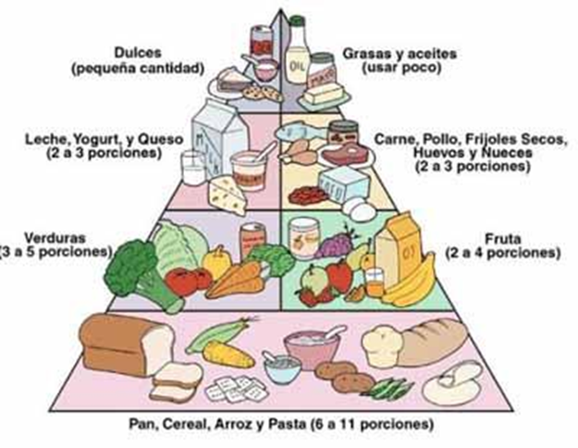
Pirámide Nutricional

DAY THREE: PRESENTATIONAL

D. Writing: Design a menu for a healthy one-week school lunch menu.
- Be sure that each day uses different food items.
- Use foods from at least 4 different food groups each day.
- Inform the lunchroom staff why they should use this menu instead of the meals that were on your school lunch menu. (p.5)

lunes | martes | miércoles | jueves | viernes

Este menú es más saludable que el menú de nuestra escuela porque…
____________________________________________________________________________________________________________________________________________________________________________________________________________________________________________________________________________________________________________________________________________________________________________________________________________________________________________________________________________________________________________________________________________________
Español I – IPA for end of unit

Theme: Global Challenges – Food: Hunger in the World
Essential Question: Who is hungry?

To be used after a unit on hunger in the world, in which students have studied food vocabulary, nutritional food groups, the map of hunger in the world and causes of hunger.

DAY ONE: INTERPRETIVE

A. Listening: http://es.wfp.org/trabajamos-por-un-mundo-con-hambre-cero - Video from the United Nations hunger.
Read the following questions and then watch the video from the United Nations (Minimum of two times). Now answer the questions in English.

MAIN IDEAS:

1. What is the goal of the United Nation’s Programa Mundial de Alimentos?

2. What are two or more ways that the United Nations is responding to hunger?

____________________________________________________________________________
________________________________________________________________________________________________________________________________________________________________________________________________________________________________________________________________________________________________________________

INFERENCES:
1. Why does the video reference the United States, Canada and the European Union together?
____________________________________________________________________________________________________________________________________________________________________________________________________________________________________

B. Reading: http://es.wfp.org/hambre/datos-del-hambre - United Nations data on hunger. (Article follows)

I. KEY WORDS: In this article, find the words in Spanish that best express the meaning of the following English words or phrases:

1. AIDS - _____________________________
2. sufficient - ___________________________
3. developing nations - _______________________________
4. risk - _____________________________________
5. malnutrition - ____________________________________
6. underweight - _____________________________________
7. school age - ________________________________________
8. stunted growth - ___________________________________
9. percentage - _________________________________________
10.estimates - ________________________________

II. MAIN IDEAS: Answer in English.
1. Why is world hunger a major problem? Cite evidence from the article.

____________________________________________________________________________________________________________________________________________________________________________________________________________________________________________________________________________________________________________________________________________________________________________________________

III. SUPPORTING DETAILS:
1. Circle the letter of each detail that is mentioned in the article – not all are included!
2. Write the letter of the detail next to where it appears in the text.

A. Malnutrition causes almost half of the deaths of children under 5 in the world.
B. The large majority of those who suffer from hunger live in developing (third-world) countries.
C. Africa is the continent with the most hunger.
D. Women need more access to agricultural resources.
E. One in four of the world’s children do not grow as they should.
F. Hunger kills more people worldwide than malaria, tuberculosis and AIDS combined.
G. If students attend classes on hunger and nutrition, this would help the problem.
H. It would take millions of dollars to feed the hungry school-age children around the world.

IV. INFERENCES:

1. It appears that the authors of this article are much less optimistic about eradicating hunger than the authors of the video in the world. Use evidence from this article to help explain why getting rid of hunger would be so difficult.
________________________________________________________________________________________________________________________________________________________________________________________________________________________________________________________________________________________________________________

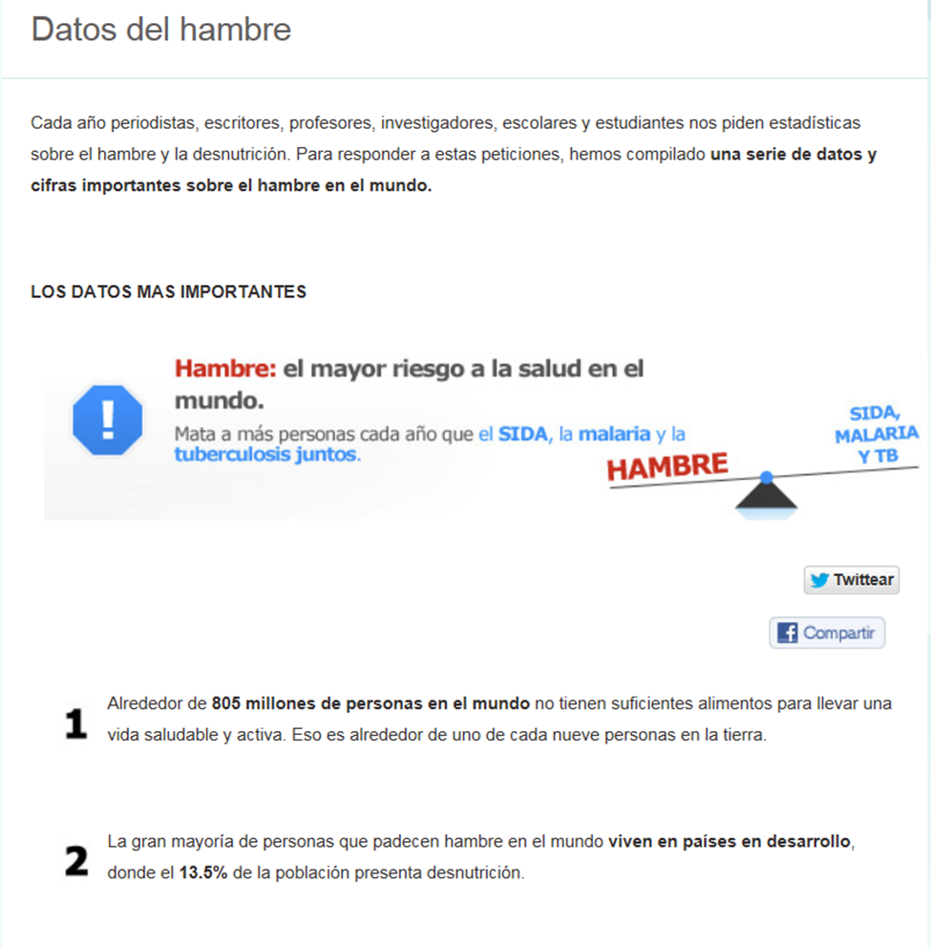
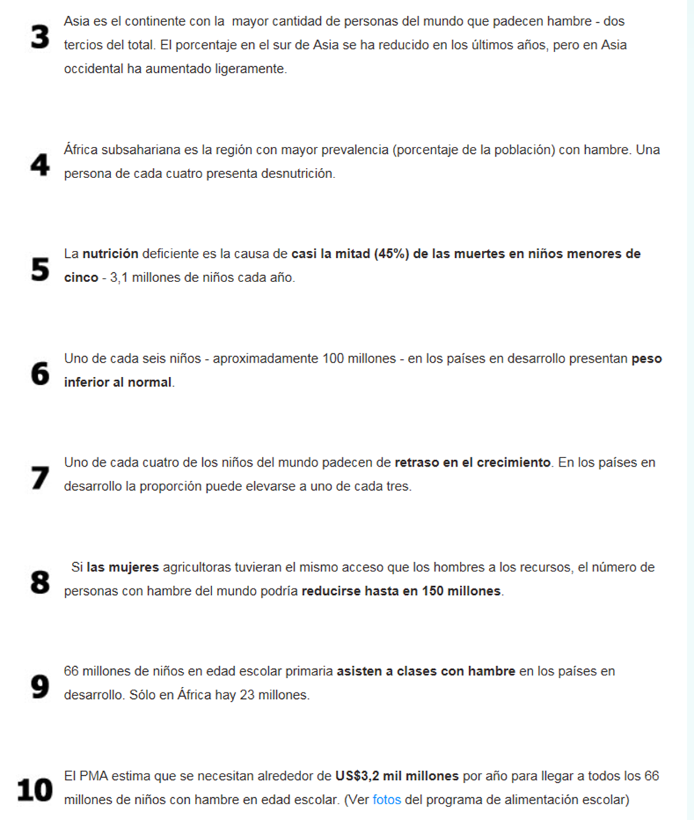

DAY TWO: INTERPERSONAL

Study the Pirámide Nutricional and become familiar with the food groups. Also study the pictures from three countries on “What the World Eats.”
Then do the activities that follow the pictures.

Pirámide Nutricional

What the World Eats
http://time.com/8515/hungry-planet-what-the-world-eats/

Los Estados Unidos: Los Fernández de Texas – Gasto en alimentos por una semana: $242.48. Alimentos favoritos: Gambas con salsa, mole de pollo, costillas a la barbacoa, pizza.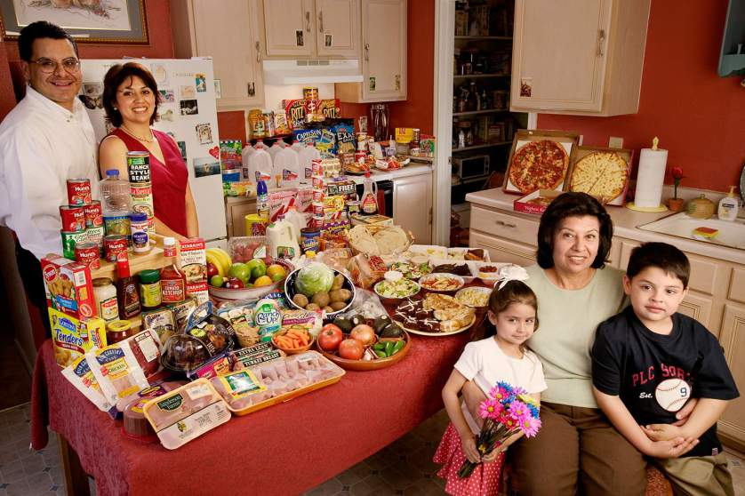

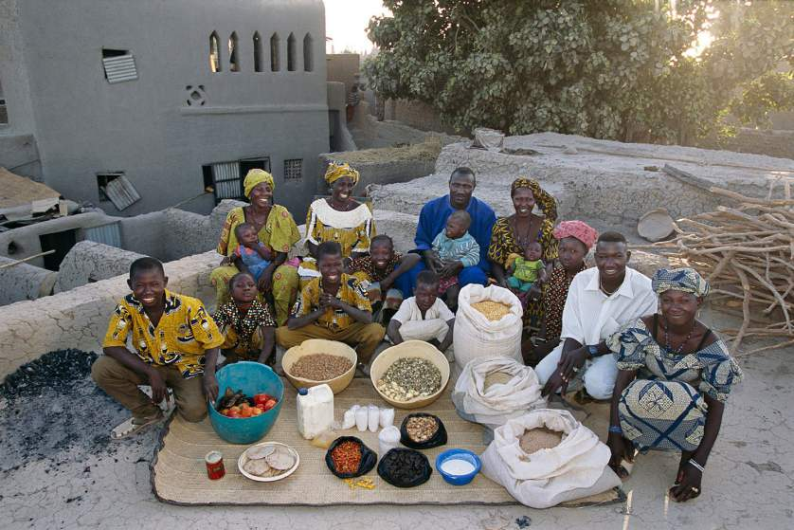

Mali: Los Natomos de Kouakourou - Gasto en alimentos por una semana: $26.39.
Alimentos favoritos: receta con arroz (de la familia)

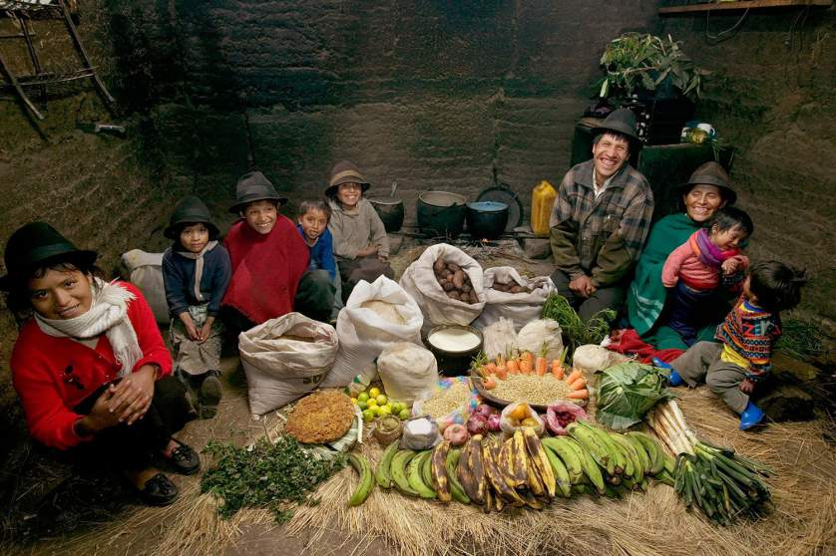
Ecuador: La Familia Ayme de Tingo. Gasto en alimentos por una semana: $31.55.
Alimentos favoritos: Sopa de patatas con col.

I. Fill in this chart with foods that you can identify from the photos of the three countries. Use this organizer and the Pirámide Nutricional to prepare for the Interpersonal conversation. (Note to Teacher: This chart should not be graded.)
Country: Estados Unidos | Country: Ecuador | Country: Mali

C. Conversation:
(Groups of two- three students. 5-6 minutes per group. Assessed with individual interpersonal rubrics for each student.)
Each person in your group will represent one of the three countries in the pictures that you studied. Discuss these questions:
1. What do they eat in your country?
2. The majority of food in your country comes from what food group(s)? Is this healthy or not
healthy?

3. Does your country need more foods from some of the food groups? Which food groups?
Why or why not?

4. Do you think that hunger or malnutrition (desnutrición) are problems in your country? Why or
why not?

5. What can we do to help with the problem of hunger or malnutrition in your country?

DAY THREE AND FOUR: PRESENTATIONAL

D. Choose a country in the world that has a problem with hunger and do some research on what they what they eat. Imagine that you are the United Nations student representative from this country. Prepare a PowerPoint or Prezi that you will present to U.N. General Assembly providing information on the problem of hunger and the causes of hunger in your country, and the help that you are seeking from the U.N.

Some helpful websites:
http://documents.wfp.org/stellent/groups/public/documents/communications/wfp275098.pdf - Map of world hunger (Should be projected, as this copy is very difficult to read)
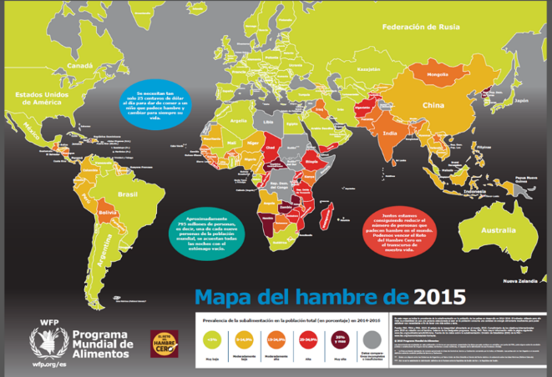

http://time.com/8515/hungry-planet-what-the-world-eats/ - Photos of what people eat in many countries.
http://www.accioncontraelhambre.org/area_actuacion.php - causes of hunger

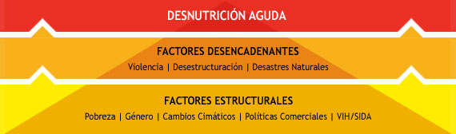

The information in your presentation should include the following:
- The location of your country
- The influence of geography on your country (Is it near the ocean? Are there deserts or rivers?
- Data on why hunger is a problem in your country.
- What the majority of people eat in your country. Is this healthy? Why or why not? Are they lacking certain food groups?
- What help are you looking for from the United Nations?
- Español I – IPA for end of year

- Theme: Global Challenges – Food: Hunger in the World
- Essential Question: Who is hungry?

To be used at the end of the year in which students have studied food, weather, family, clothing, free time activities, chores and house vocabulary; description, present time frame, expressing opinions, likes and dislikes.

DAY ONE: INTERPRETIVE

A. Listening: http://es.wfp.org/trabajamos-por-un-mundo-con-hambre-cero - Video from the United Nations hunger.
Read the following questions and then watch the video from the United Nations (Minimum of two times). Now answer the questions in English.

MAIN IDEAS:

1. What is the goal of the United Nation’s Programa Mundial de Alimentos?

2. What are two or more ways that the United Nations is responding to hunger?

____________________________________________________________________________________________________________________________________________________________________________________________________________________________________________________________________________________________________________________________________________________________________________________________

INFERENCES:
1. Why does the video reference the United States, Canada and the European Union together?
____________________________________________________________________________________________________________________________________________________________________________________________________________________________________

B. Reading: http://es.wfp.org/hambre/datos-del-hambre - United Nations data on hunger.
(Article follows)

I. KEY WORDS: In this article, find the words in Spanish that best express the meaning of the following English words or phrases:

1. AIDS - _____________________________
2. sufficient - ___________________________
3. developing nations - _______________________________
4. risk - _____________________________________
5. malnutrition - ____________________________________
6. underweight - _____________________________________
7. school age - ________________________________________
8. stunted growth - ___________________________________
9. percentage - _________________________________________
10.estimates - ________________________________

II. MAIN IDEAS: Answer in English.
1. Why is world hunger a major problem? Cite evidence from the article.

____________________________________________________________________________________________________________________________________________________________________________________________________________________________________________________________________________________________________________________________________________________________________________________________

III. SUPPORTING DETAILS:
1. Circle the letter of each detail that is mentioned in the article – not all are included!
2. Write the letter of the detail next to where it appears in the text.

A. Malnutrition causes almost half of the deaths of children under 5 in the world.
B. The large majority of those who suffer from hunger live in developing (third-world) countries.
C. Africa is the continent with the most hunger.
D. Women need more access to agricultural resources.
E. One in four of the world’s children do not grow as they should.
F. Hunger kills more people worldwide than malaria, tuberculosis and AIDS combined.
G. If students attend classes on hunger and nutrition, this would help the problem.
H. It would take millions of dollars to feed the hungry school-age children around the world.

IV. INFERENCES:

1. It appears that the authors of this article are much less optimistic about eradicating hunger than the authors of the video in the world. Use evidence from this article to help explain why getting rid of hunger would be so difficult.
________________________________________________________________________________________________________________________________________________________________________________________________________________________________________________________________________________________________________________

DAY TWO AND THREE: INTERPERSONAL

Study the pictures from two countries on “What the World Eats.”

C. Conversation:
(Groups of two students talking with the teacher. 5-6 minutes per group. Assessed with individual interpersonal rubrics for each student.)
1. What foods do they eat in each country?

2. Do you think that each country has a healthy diet? Why or why not?

3. What types of clothing do you see in each country? Describe what you see.

4. What does the clothing tell us about the climate of each region?

5. Describe the family in each country. How are the families
the same? How are they different?

6. What differences in the houses do you see? What do you think might be other differences in
housing?

What the World Eats
http://time.com/8515/hungry-planet-what-the-world-eats/

Los Estados Unidos: Los Fernández de Texas – Gasto en alimentos por una semana: $242.48. Alimentos favoritos: Gambas con salsa, mole de pollo, costillas a la barbacoa, pizza.

Las Montañas del Ecuador: La Familia Ayme de Tingo. Gasto en alimentos por una semana: $31.55. Alimentos favoritos: Sopa de patatas con col.

DAY FOUR: PRESENTATIONAL

D. Writing: Students may use the photo from Ecuador.

You are on a humanitarian aid trip to Ecuador for one month. You are living with a family in the region that you are helping, similar to the family in the picture. This is a very different living experience for you, but you are adapting and you like the family and the new experiences. Write a letter home to your family describing your experience in this remote region in Ecuador. Give as much information as possible about the following topics:

1. Describe the family with whom you are staying.
2. Talk about the weather and the clothing you are wearing. What other clothing or accessories
do you need your mother to send you in order to be more comfortable?
3. Talk about the food you eat in a typical day. Talk about the foods that you like and the foods
that you miss.
4. Talk about what you do in your spare time. Include what you for fun, places to go, chores
that you have to do and how doing these chores may be different here than at home. (ex.
washing your clothes)
5. Talk about what you are doing to help in this village. (ex. Teaching English, math, nutrition?
Building a school?)

I. Graphic Organizer- Fill in this organizer in English or Spanish before you begin to write to put your thoughts in order and then write the letter.

Family (description)

Weather

Clothing I have
Clothing I need

Food I eat

Food I like
Food I miss
Fun Activities

Places to go
Chores

Differences in doing chores
What I am doing

