FRENCH 1 – INTEGRATED PERFORMANCE ASSESSMENT
Thème : les passe-temps

Years have passed since you graduated from Wyoming High School and you have now realized your dream of living in Paris, France. On your first night in your new tiny apartment in the heart of Montmartre, you surf the web hoping to find activities you can do in the city during your free time. You come across the Paris city hall website. You will first read and interpret the information presented on the site, then you will talk with your friends about which activities you like doing, and finally you will write a short blog post.

Learning objectives:
I can comprehend main ideas and some details on a francophone website about week-end activities.
I can express my likes and dislikes using words, phrases and memorized expressions.
I can ask very simple questions and give simple responses about a familiar topic.
I can write about myself using learned phrases and memorized expressions.

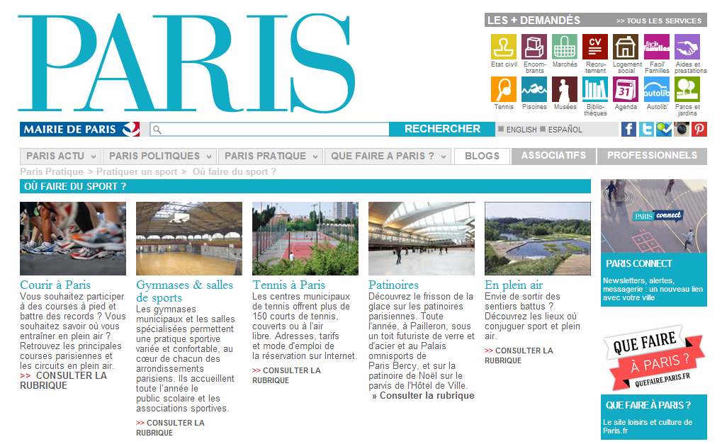
Source: http://www.paris.fr/pratique/pratiquer-un-sport/ou-faire-du-sport/p151

FRENCH 1 - INTERPRETIVE PERFORMANCE ASSESSMENT
Thème : les passe-temps
Source : http://www.paris.fr/pratique/pratiquer-un-sport/ou-faire-du-sport/p151

1. Key word recognition:
Find in the text the French word that best expresses the meaning of each of the following English words. Please use only words from the text. The number in parenthesis indicates the number of French words you need to find in the text.
City hall (1) _______________
Running (1) _______________
Ice rink (1) _______________
Fitness centers (3) _______________
Outdoor (3) _______________
Tennis courts (3) _______________

- Objective and audience:
Explain at least three (3) primary objectives of this website (in English):

Who do you think the audience of this website is? You may have multiple answers.

- Supporting details:
First, circle the letter of the three (3) details mentioned on the site. Then, write the letter of that idea next to where it appears in the text.
- You can practice a variety of sports in Paris.
- There is a Christmas ice rink in Paris.
- There are over 300 tennis courts in Paris.
- You can practice sports indoor or outdoor in Paris.
- There are no specialized fitness rooms in Paris.
- Organizational features
How is the text organized? Justify your answers.
A. Chronological
B. Pros and Cons
C. Cause and effect
D. Compare and Contrast
E. Informational

What is the justification? Be specific

INTERPRETIVE RUBRIC
NOVICE  INTERPRETIVE | Stretch | A+ A A- | B+ B B- | C+ C C- | D+ D D-
Literal Comprehension | Recognizes all of key words  Explains all the objectives and audiences of the text  Identifies and correctly locate all supporting details | Recognizes most of the key words  Explains most objectives and audiences of the text  Identifies and correctly locate most of the supporting details | Recognizes some of the words  Explains some of the objectives and the audiences of the text  Identifies and correctly some of the supporting details | Recognizes at least one word  Explains at least one objective and one audience of the text  Identifies and correctly locate at least one supporting detail | Does not recognize any key word  Does not explain any objectives or the audience of the text  Does not identify any supporting detail or may identify supporting detail but cannot locate them in the text.
Interpretive Comprehension | Identifies the organizational feature(s) of the text and provides an appropriate rationale | Identifies the organizational feature(s) of the text; rationale may miss some key points | Identifies in part the organizational feature(s) of the text; rationale may miss some key points. Or identifies the organizational feature(s) but rationale is not provided. | Identifies in part the organizational feature(s) of the text; attempts to provide a rationale, but is not successful. | Attempts to identify the organizational feature(s) of the text but is not successful.

FRENCH 1 - INTERPERSONAL PERFORMANCE ASSESSMENT
Thème : les passe-temps

After looking at the activities offered by the Paris city hall, discuss with your friends:
- Which activities you like on the site
- How often and how well you do this activity (if applicable)
- If there are no activities that interest you, state what you like to do to the week-end and how often / how well you do things (if relevant)
- Make sure to keep the conversation alive by asking each other questions

Interpersonal rubric will be used to assess you.
FRENCH 1 - PRESENTATIONAL PERFORMANCE ASSESSMENT
Thème : les passe-temps

You notice that the site has a “blogs” tab. After clicking on this tab, you find a bunch of posts by Parisians stating what they like and don’t like to do on the week-end. You decide to post your own contribution:

- Introduce yourself: Name, age, nationality
- Talk about 1-2 activities you like to do on the week-end and 1-2 activities you don’t like to do on the week-end
- Provide more details where relevant

Presentational writing rubric will be used to assess you.

Assessment prepared by C. Lainé according to guidelines in ACTFL Integrated Performance Assessment ©2003.
Created: 11/13/2013 Wyoming City Schools
Modified: 03/04/2014

